We have a fairly simple project written in the Vue.js framework. In fact, the database for it is an Excel file. In general, the idea is to display personal information, or more precisely, sports achievements of different users. 

Here we see a filled-in Excel table with user data recorded: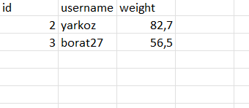 

We select one of the accounts and log in.

The id in the line of each user determines which page we will be redirected to next. The user id corresponds to the sheet number in Excel (Sheet X), where X is the user id

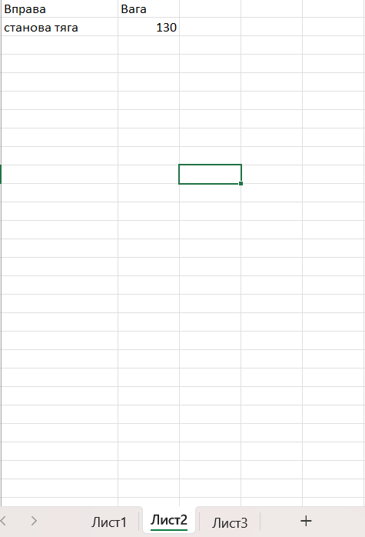

After the event, we see the information from the corresponding sheet and the user's weight, which was recorded in the row. 